INDEPENDENT RESEARCH PROJECTS DUE ________________

As a requirement to pass the classroom, you need to pick ONE research project from the list below.

Paper: Minimum 2 pages typed, single spaced (4 hand written). Include separate title page, and sources of information. Sources of information include: books, websites, newspapers, pamphlets, owners manuals, insurance companies, police, etc.

After submitting your paper, you will be “tested” on what you have researched. In class, you will hand write a 1 page summary of your findings plus an application of how it applies to your life.

1) Emotions, attitudes, and distractions when driving: How can anger, depression, excitement, and even happiness, affect your ability to drive? Give some teenage examples of these things. Also cover what you can do to control your emotions while driving? How can you as a passenger help a driver who is emotional? Also discuss "show-off" driving... …why are some teens are tempted, how do others view this behavior, possible consequences of it. Discuss typical distractions teenage drivers must deal with and give some tips on dealing with them effectively.

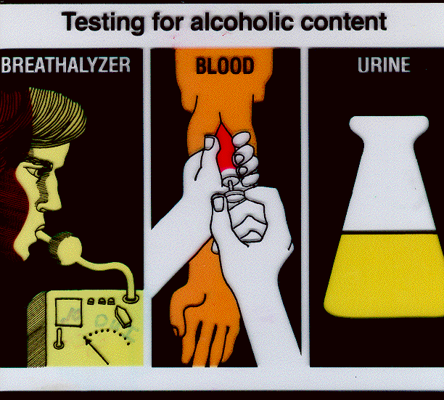
2) Being arrested for Driving Under the Influence (DUI): Provide information showing what happens during a DUI arrest. (check with a police officer to find out what tests are now used. Include what happens at the car, along the road (field sobriety test), and at the station. Also discuss penalties for conviction.

3) Seat belts, child restraints & air bags: As far as seat belts are concerned include statistics, current law, how they work, how to properly wear and adjust them why they are required by law, objections people raise for not wearing them, and answers to these objections. As far as airbags are concerned include: how they work, when they won't work, and situations when they could be dangerous.

4) Driving in adverse conditions: Deal with: glare, fog, heavy rain, ice slick roads, and snow. Also discuss how to get unstuck in snow, hydroplaning, and anti-lock brakes. Also touch on driving in extremely hot weather and in high winds.

5) Peer pressure: Include general information on both positive and negative peer pressure. Include: drinking and driving, drag racing, and wearing seat belts showing the positive and negative influences of peer pressure.

6) Accident procedures & Insurance: Discuss what to do if involved in a collision. Explain the various types of car insurance and what they cover. Call up your parent’s insurance agent and get a quote on what it will cost to add you to your parent’s policy as a 25% occasional driver for 6 months & compare that with what it will cost you if you had “full coverage” on your own car. (car of your choice – eg. 2009 Corvette)
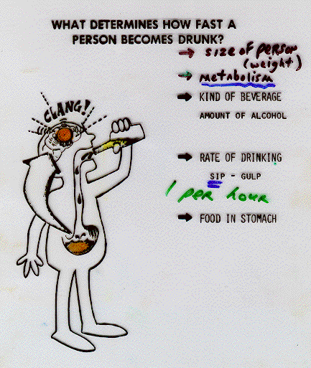

7) Affects of alcohol & drugs on driving: Present some statistics, how alcohol affects mental & physical abilities needed for driving, factors that determine effects of alcohol, myths about alcohol, and include how you personally feel about alcohol and driving. Also discuss the effects of marijuana on driving.

8) Motorcycle safety: Discuss special precautions cyclist must take, why car motorists must be extra careful, where car drivers should look for cyclists, how cyclists need to protect themselves, handling characteristics of cycles, protective equipment to wear, special problems they face, and anything else you can think of...

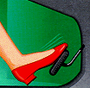
9) Driving emergencies: Describe how you should deal with these vehicle malfunctions: stuck accelerator, brake failure, steering failure, hood flies up, a flooded engine, tire blowout & overheated engine. Explain what they are, what causes it, and how to deal with it. In addition discuss what to do if your car catches fire and if it stalls on railroad tracks.

10) If you've been involved in a serious accident you will give a summary of all the things that happen before, during, and after the accident. Include the emotional state of the driver before the accident. Discuss short & long term consequences of all involved.

